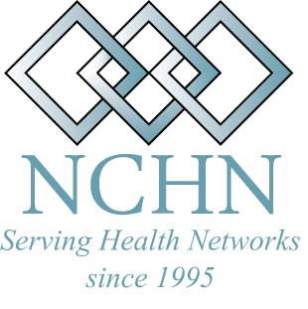
National Cooperative of Health Networks Association

News Release

MEDIA CONTACT: Rebecca Davis, Ph.D., Executive Director RELEASE DATE: April 30, 2010
270-925-5611
RDavis@NCHN.org

LOCAL LEADER WINS NATIONAL AWARD

Cindy Large of Terre Haute, IN --- Outstanding New and Emerging Health Network Leader of 2010
On April 19, 2010, the National Cooperative of Health Networks Association (NCHN) announced their second national award winners during their annual conference in San Antonio, Texas. Cindy Large, Executive Director of the Indiana Statewide Rural Health Network (InSRHN), was selected as the recipient of the NCHN Outstanding New and Emerging Network Leader Award.
The NCHN Outstanding New & Emerging Network Leader of the Year Award recognizes extraordinary leadership activities demonstrated by a new health network leader with less than five years experience in the field. Award winners were nominated and chosen by their national peers.
Large was specifically recognized her for efficiency as a network leader and her ability to inspire and instill confidence in other leaders who are just embarking on the formation of networks. “Cindy’s nomination said it best,” adds Rebecca Davis, Executive Director of NCHN. According to one member who nominated Large, “Cindy has inspired and encouraged me to move forward with my leadership as Grant Coordinator for our Network Planning Grant.” As a presenter at the 2008 NCHN Annual Conference in San Diego, “She was both welcoming and authentic,” the nominator said. “Her first words, ‘I was sitting in your seat last year, and I didn’t have a clue what I was doing!’ She shared her experience in such a way, that not only did I visit with her at the conference, I’ve called and written her several times since. At the end of each conversation I left with the sense that I know I can do this...”
Large served as the leadership for the initial grant application which gave rise to the Indiana Statewide Rural Health Network in 2008. She assembled partners with the expertise and connections to rural heath, to create a cohesive group of hospitals in rural Indiana, that are working together to improve the quality of and access to healthcare in Indiana’s underserved communities. In just two years, Large has created a fully sustainable network based on a unique combination of membership fees, grant collaborations and partnerships, usage fees and administrative fees. The InSRHN provides an extremely low cost, high return, model to provide each member with substantial return on investment for their time and financial commitment. In 2009, under Cindy’s leadership, the Network achieved a 477% return on investment for its individual members.
By definition, health networks are formed when three or more health care providers formally come together to better meet the needs of patients in their service area. These providers often include hospitals, community health centers, critical access hospitals, physician practices, mental health providers, rural health clinics and other for-profit and not-for-profit health care organizations. These networks work to increase access to quality health care for local patients and streamline the cost of that care, as well.
NCHN is a national level professional membership organization of health network leaders across the nation. Its mission is to support and strengthen health alliances through collaboration, networking, leadership development and education. The Association has members in 33 states. Its major focus in 2010 will be a continued emphasis on supporting Network Leaders across the nation through the expansion of the Executive Coaching Program, ongoing regional conferences and workshops, and the development of a Certification Program for Network Leaders.
For more information please go to www.nchn.org

